Authorization for Electronic Payment

The Thompson Foundation for Autism can receive payments from you, or your company, using the Automated Clearing House (ACH) Network instead of paper checks. The process is simple, fast, and more secure than check payments by mail. If you would like to receive notifications via email, please submit your email address in Section One.

Form Instructions: Please complete Sections One, Two (if applicable) and Three of this form. Keep a copy of this form for your records and send the form to:

EMAIL COMPLETED FORM TO: myles@thompsonfoundation.org

Section One – Bank Account Information – Please complete the following bank account information.

* Indicates Required Fields (ABA # is required for banks in the US - or - Institution # and Branch # are required banks in Canada)

* Type of Account: Business (Skip Section Two)  Individual |  | * Sub Type:  Checking Savings Other
* Name on Account as shown on bank records:

* Bank Name: |  | * Bank Country:
* US Bank ABA Routing Number (9 digits): |  | Bank Phone:  (Optional)
* Canadian Bank Institution Number:  (3 digits) | * Canadian Bank Branch Number:  (5 digits)
* Bank Account Number:

Email Address:

Note: If your bank account closes, please complete and submit a new form with your updated banking information. Allow two weeks for the conversion to your new bank account. An example of where to locate banking information on a check is provided on page 2.

Section Two – Attach a Void Check (Optional)

If ACH payments will be made from an individual's (non-corporate) bank account, we request that you attach a voided check to this form. Attaching a voided check will help ensure accurate banking information is applied to your account. If you do not wish to attach a voided check, please double-check that the banking information above is accurate and legible.

Section Three –Authorization to Receive ACH Payments

I CERTIFY THAT I AM THE OWNER OF THIS BANK ACCOUNT OR AN AUTHORIZED REPRESENTITIVE OF THE COMPANY STATED BELOW:

Company Name
Federal Tax ID | (Optional)
Name
(Printed)
Title
Signature /
Date
Contact Phone Number

If you have questions, please contact Executive Director Myles Hinkel at (573) 884-0777.
Authorization for Electronic Payment

Locating your ABA Number - US Check Example

The ABA routing number appears on the bottom of your checks (known as the MICR line).
The ABA number is the 9-digit number starting on the left, before your account number.

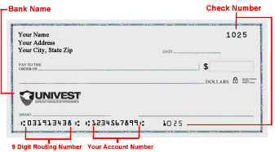

Locating your Routing Numbers - Canadian Cheque Example

The Branch and Institution routing numbers appears on the bottom of your cheques (known as the MICR line).
The Branch number is the 5-digit number, and the Institution number is the 3-digit number.

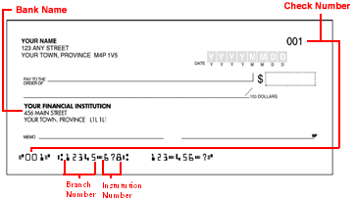

If you do not have checks, check your bank's website. You should be able to find the routing number(s) for your bank on the support, customer service or FAQ pages. You can also call the bank and ask a customer service representative.

